The following supplementary resources, in conjunction with the original assessments, course evaluation handout and plan of instruction may be reproduced by instructors.

Appendix I Training Needs Analysis

Customer Training Needs Analysis
Participant Name |  |  | Participant #
Participant Address
Contact #1 Name |  |  | Contact #2 Name
Contact #1 Phone Number |  |  | Contact #2 Phone Number
Contact #1 Email Address |  |  | Contact #2 Email Address
Consultant (Trainer)  Assigned |  |  | Assigned Date  (mm/dd/yyyy)
Date of Needs Analysis  (mm/dd/yyyy) |  |  | Relationship Manager
Projected Activation Date  (mm/dd/yyyy) |  |  | Projected Approval Date  (mm/dd/yyyy)
Type of Training |  |  | Customer Experience -  Settlement
During Needs Analysis, Client Side Represented by (Names & Dept.):
Training Topic Needs | - Industry knowledge Repo Service SuiteABC REPO® Service Suite |  | (3 courses) □ DP Navigation Service Suite (3 courses)  (3 courses) □ SD Risk Management Course
Staff to be Trained (#,
Names and Departments
Represented)
Subsidiary Membership | □ TC | □ | RPD □ MS □ NCC
Customer Type |  |  | Settling / Clearing Bank
Security Types
Service Type | - Clearing (CIT™ Rep  - Clearing (Netting)  - Comparison Only |  | □ Clearing ( Netting)
Number of Transactions  Per Day |  |  | Activation Approval Status
Trade Input Method | □M Web (Manual) □ □ I Message (IM)  Transmission via Batch
Processing Platform | - Service Bureau  - Web Front End □ Other
FTP Interface with
Current Relationships
Current Dealer
Relationships
Customer Training Needs Analysis (Cont.)
Impediments
Member Concerns
Next Steps
Comments

Appendix II Audience Analysis

SECURITIES
Overview
What is the estimated size of the customer segment (number of people, not firms)? | Few hundred clients
Where is each customer segment geographically distributed? | Global, domestic

Organizational Environment
What types of organizations (banks, brokers, dealers) make up this segment? | Brokers, custodial banks, hedge funds, asset managers
What are the job functions or duties of typical users in this segment? | Processers, traders.
What is the range of skills of typical users in this segment? | n/a

Physical Attributes
What is the age range of customers in this segment? | 40-60 average

Skills and Knowledge
How much job experience should customers have in order to use the product? Use the following values:  1: Little or no knowledge of the subject  2: Understanding of basic concepts, processes, and operations associated with the product (business knowledge and DTCC knowledge)  3: Ability to solve problems and apply knowledge to real-life situations | 2
How frequently do or will customers use the product (for example, daily, weekly, monthly)? | Daily usage
How proficient are customers in using computers in general?  1: Little or no proficiency  2: Some proficiency in using software, including use of  - Basic commands across applications and platforms  - Applications such as word processing, spreadsheet, database, or desktop publishing  3: High level of proficiency in using software, including  - All functions in level 2, plus  - Knowledge of operating systems and how they function  - Troubleshooting of problems before contacting technical support | 2
How proficient are customers in using Internet applications and the Web? Use the following values:  1: Little or no proficiency  2: Some proficiency in using the Internet, including  - Interaction with others using e-mail  - Ability to find information using basic search criteria in portals such as Yahoo! or Google  - Uploading and downloading of files  - Hands-on practice in launching and viewing Web pages  - Understanding of how to log onto and access functions to perform simple tasks related to the product (inquiry and update)  3: High level of proficiency in using the Internet, including  - All functions in level 2, plus  - Ability to determine the authenticity and reliability of data gathered from information sources  Ability to perform complex tasks (such as researching and troubleshooting) | 2
How much industry knowledge do customers typically have? Use the following values:  1: Beginner (less than two years)  2: Intermediate (2-5 years)  3: Advanced (more than five years) | 3
How much experience do customers typically have interacting with its subsidiaries? Use the following values:  1: Beginner (less than two years)  2: Intermediate (2-5 years)  3: Advanced (more than five years) | 3
What is customers’ current level of knowledge of the product? Use the following values:  1: Little or no knowledge of the subject  2: Understanding of basic concepts, processes, and operations of the product  3: Ability to solve problems and apply knowledge to real-life situations  s  -customers understand basic concepts, processes, operation role functions. | 2
What related products - | @ Source is security type, cusip level details, security types  Validation Service is Corporate Action Announcement date and event types- tender offer, redemption, P&I, etc.
Have customers been previously trained in the product? | Yes, webinars were created to highlight this product and highlight format changes and new process.
If the answer to the previous question is Yes, what training have target customers previously had that will prepare them for training in this product? | Webinars, customer site visits.
What is customers’ desired level of knowledge of the product? | To utilize daily, functional knowledge.
What is the average educational level of customers?  1: High school level  2: Undergraduate level  3: Postgraduate level | n/a

Appendix III LESSON(S) RUBRIC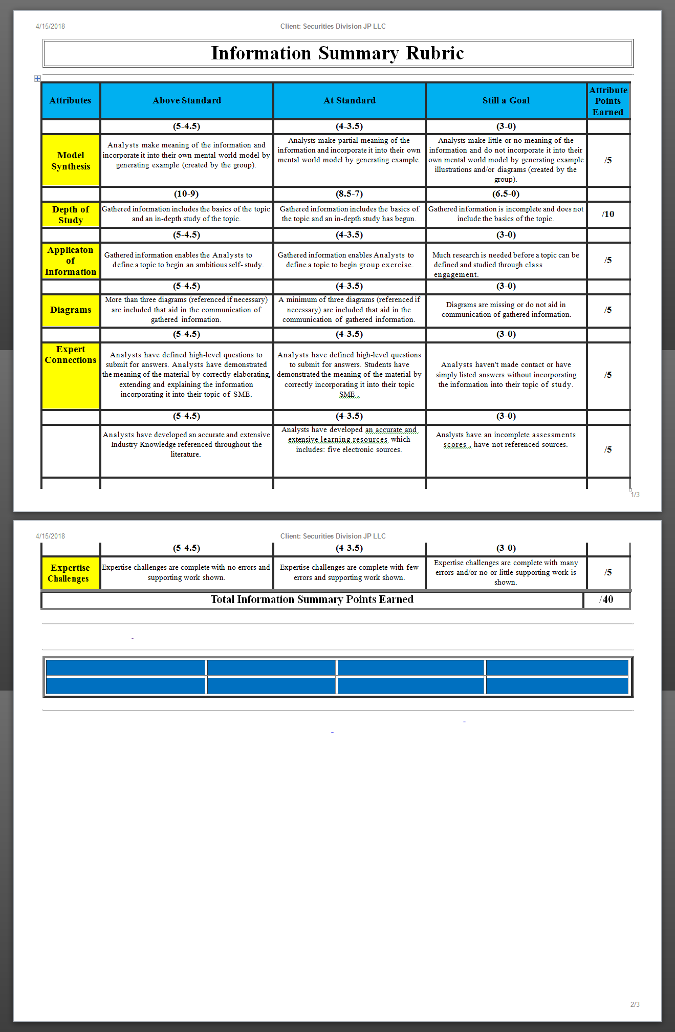
Appendix IV Course 2 Title: Gov. Securities Processing Overview Course - Assessment

Question 1:
For GGCF, a dealer is either a ________________ or a _______________ at the GF Generic CUSIP level.
- Net securities borrower (cash lender) or a net securities lender (cash borrower)
- Net broker or a net banker
- Net cash borrower (securities borrower) or a net cash lender (securities lender)
- Member or a Non-Member
Question 2:
Fill in the blank field below with the correct word that best completes the sentence.
The value of the GCCF changes daily based on the System Repo Rate and the ______________ to Date.

Question 3:
Choose whether the below statement is true or false.
Comparison only Member trades that are submitted, compared and eligible for netting is then aggregated and matched on a multi-lateral basis on the day of settlement.

Question 3:
Select the correct answer from the below choices that best answers the question.
During the RTTMT Trade Submission process flow, what is the trade status on the message sent by TMM to the Inter-Dealer Broker, after the Inter-Dealer Broker submits a locked-in trade?
- Comparison Pending
- Affirmed
- Pending Affirmation
- Pending Cancel

Question 4:
Fill in the blank field below with the correct word that best completes the sentence.
For the Start of Day Funds Settlement cycle, Members' settling banks must acknowledge the credits and debits on their behalf by _______ in the morning.

Question5:
Choose whether the below statement is true or false.
The interest accrued on a GCCF trade settled through the Intraday Funds-Only Settlement process.
TRUE____________ FALSE___________

Question 6:
Choose whether the below statement is true or false.
Report Center is a centralized location within FICC RTTMÂ® Web that enables participants to access current and historical reports both intraday and end of the day, using a standard web browser.
TRUE _____ FALSE______
Question 7:
If the last day of the month is the 31st and that day falls on a Saturday, the invoice will be published to Report Center on the _______ even if that day falls on a weekend.
- 30th
- 15th
- 31st
- 10th

Question 8:
Select the correct answer from the below choices that best answers the question.
Based on the reference slides showing each reports' display fields, which of the below descriptions correctly explains what the term Final Money means?
A. The close leg settlement amount, calculated by the system using the start amount, rate,
B. Start date and settlement date
C. The start leg settlement amount

Appendix V -Course Title: System Navigation Overview Course – Assessment

Question 1:
TMC allows Members to perform trade entry, modifications, affirmations and cancellations, by using Standard ISO Formats and 15022 SMART (MQ) messages.
TRUE ________ FALSE _________

Question 2:
If you have trouble logging into the PLBM Web application, you may contact ______________ to reset your password.
- TBAC Operations
- The CCCC Client Support Center
- Your IT Department
- Your Access Coordinator
- The CCCC Operator
Question 3:
Which tab would you navigate in the main toolbar, to change your password or manage a user’s access?
- Trade Management
- Business Administration
- Site Administration
- Help

Question 4:
Any trade that is archived in the GCF RTTMÂ Web application can be __________ by selecting the magnifying glass icon next to the trade.
- Modified
- Canceled
- Viewed
- Deleted

Question 5:
Trades in the Cancel Request (CPNR) or Pending Cancel (PNN) Trade State may be ______________ by GOV Operations at the request of the GDB Member if a request submitted via email before that days’ net.

- Un-canceled
- Deleted
- Archived
- Auto-affirmed
Question 6:
When entering a GFF Repo transaction into TTTP Web, individuals can enter trades against contra ID’s who settle/clear through both JLL Securities and BNY.
TRUE ________ FALSE _________

Question 7:
Dealer Members execute CGCF through ______________ who will submit trades on their behalf.
- Other Dealer Members
- Settling Banks
- Inter-Dealer Brokers
- JLCC Operations

Question 8:
Which trade state tab on the Overall Position Monitor screen displays trades for which a counterparty has processed an attempt to cancel action on an already affirmed trade, resulting in a cancel request made to, the dealer?

- Pending Affirm (PF)
- Pending Affirm (PA)
- Cancel Request (CR)
- Advisory (AD)
Question 9:
Subject: Trade State Types

The __________ trade state represents trades for which a counterparty has processed an attempt to cancel action on an already affirmed trade, resulting in a cancel request being made to the viewing Member. The viewing Member can action the request to cancel, thus thoroughly removing the trade from the net.
- Canceled (CAN)
- Pending Cancel (PCN)
- Advisory (ADV)
- Cancel Request (CNR)
Question 10:

What is the max par size a CBCF trade can be submitted for via Interactive Messaging (IM)?
- 2,000,000,000
- 9,999,999,999
- 2,999,000,000
- 9,999,000,000

Question 11:
The Comments section of the CCF Homesite in the CCGF Web application is used by JLC Operations to post alerts or announcements informing Members quickly about issues during a calendar day.
TRUE ________ FALSE _________

Question 12:

The Quick Links feature in the QCF Web application allows you to navigate to the Overall Position Monitor and the Trade Entry screen.
TRUE ________ FALSE _________

END OF ASSESSMENT

Appendix VI
Course Evaluation

Your Name: ______________________ Course Name: _______________________________ Date: ____/____/________ Instructor’s Name: ______________________________________

Strongly Agree Agree Disagree Strongly Disagree Not Applicable
If answered Disagree, Strongly Disagree, or Not Applicable; please explain why:

The exercises, examples, and simulations in this course were realistic and applicable to my job.

Strongly Agree Agree Disagree Strongly Disagree Not Applicable
If you answered Disagree, Strongly Disagree, or Not Applicable; please explain why:

I will apply new knowledge and skills learned from this training to my job.

Strongly Agree Agree Disagree Strongly Disagree Not Applicable

If you answered Disagree, Strongly Disagree, or Not Applicable; please explain why:

The presenter/trainer was able to communicate program content and lead discussions engagingly.

Strongly Agree Agree Disagree Strongly Disagree
If answered Disagree or Strongly Disagree, please explain why:

How satisfied were you with the overall program?
Highly Satisfied Satisfied Dissatisfied Highly Dissatisfied

If answered Disagree or Strongly Disagree, please explain why:

